 | Derbyshire Federation of Women’s Institutes  New 2021  Autumn Bulb Scheme for Spring Flowers | 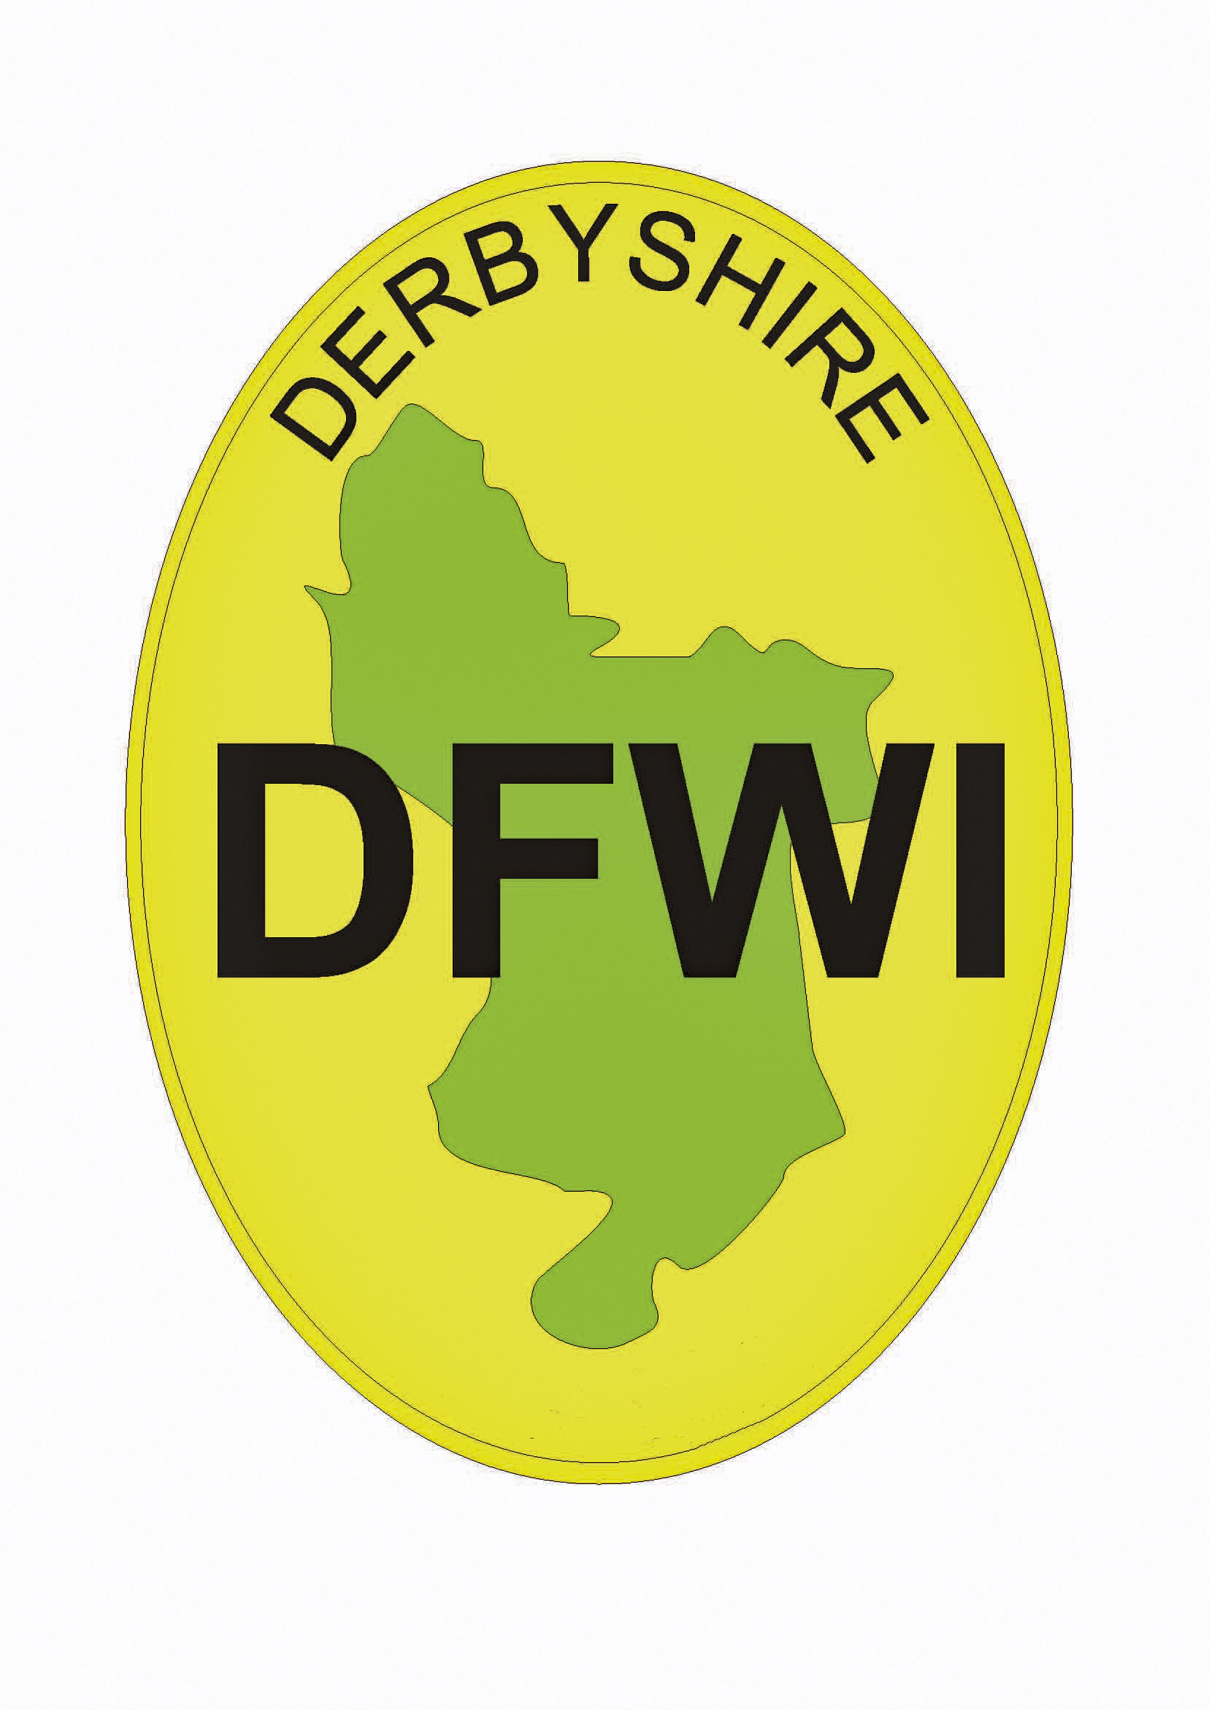
Dear Secretary,

The DFWI has pleasure in enclosing the list of bulbs they are able to supply to Institutes through Walkers Bulbs. This is the 10th year of DFWI's participation. These bulbs are of the finest quality and top size. Prices include delivery to Institutes, with no charge for orders over £25.00.

It will be necessary for your Institute to appoint a member willing to deal with correspondence and to distribute the bulbs on arrival. Three copies of the order list are enclosed, of which the blue one is retained by the Institute, the other two must be sent to: Mrs Jane Latham, The Brecklands, Coplow Lane, Foston, Derby DE65 5DL by 4th June 2021, together with a cheque which should be made payable to DFWI. Alternatively, WIs can make their payment by BACS to DFWI, Account no- 19372093, Sort Code- 83-04-25 using reference ‘WIname + bulbs’. Please DO NOT send your order to the DFWI office, only to Jane Latham (address details as above)

The special booklet with coloured illustrations of the Spring Bulbs have order forms attached. These forms should be filled in by members and given to the Institute Bulb Secretary, who will then send a bulb order for her Institute and keep the members' forms as a basis for distributing the bulbs on arrival. Orders need not be confined to Institute members, but it is requested that all orders be sent through the Bulb Secretary. All monies and cheques to be paid to the WI and one WI cheque only made payable to DFWI.

PLEASE NOTE:

- All payment must accompany the orders.
- All correspondence: Please enclose a stamped addressed envelope if a receipt is required. For all other queries, please enclose a second-class stamp. Requests for further brochures need a large letter stamp and a large envelope.
- The bulbs will be packed and despatched direct to Institutes by Walkers Bulbs.
- Autumn, ie mid-September/early October.
- Should any difficulty arise in connection with the delivery of the bulbs, such as shortage,
- non-delivery etc or questionable quality, please notify Angela Wass, Walkers Bulbs, A Division of Taylors Bulbs, Washway House Farm, Holbeach, Spalding, Lincs PE12 7PP Tel: 01406 426216.

Order forms, cheques and enquiries about financial matters should be sent to: Mrs Jane Latham, The Brecklands, Coplow Lane, Foston, Derby DE65 5DL tel: 01283 585041 or 07518 521525. Closing date 4th June 2021. The despatch of bulbs in early Autumn gives ample time for planting, but there should be no delay in distributing them.

THIS IS OUR 10th YEAR WITH WALKERS BULBS - THANK YOU FOR YOUR CONTINUED SUPPORT

Jane Latham
on behalf of the DFWI
March 2021

PLEASE RETAIN THIS LETTER UNTIL AFTER YOUR DELIVERY OF BULBS HAS BEEN CHECKED

