*PLEASE NOTE THIS COMPETITION WILL ALSO BE JUDGED AT THE
SPRING COUNCIL MEETING on the 5th March 2024
due to the CANCELLATION OF THE AUTUMN FEDERATION MEETING 2023*

Sweet Piccalilli Recipe For the Wendy Woolley Trophy October 2023
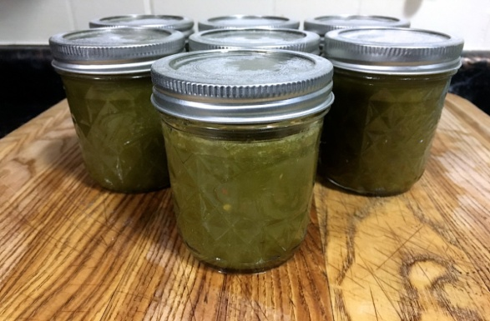
Ingredients
225g/8ozs each of Cauliflower, Cucumber, Kidney beans, marrow and shallots
1.5 pts of white vinegar
25g/1 oz ground ginger
13g/ ½ oz dry mustard
25g/1 oz turmeric
6 chillies tied in a muslin bag (optional)
25g/1 oz corn flour
170g/6 ozs Demerara sugar

Method
- Wash and prepare veg, cut into even sized pieces.
- Shake dry and either put into brine or sprinkle with salt overnight.
- Drain/shake off loose salt.
- Mix dry ingredients together, mix with a little vinegar at a time until you have a runny paste.
- Boil the rest of the vinegar sugar and chillies for 10 mins, ensuring the sugar is dissolved.
- Stir in the prepared veg, boil for 2 mins.
- Gently stir in the spice paste mix and boil for 1 min.
- Take out the muslin bag with the chillies.
- Pour into warm jars, seal, label and date.

