The Queen’s Platinum Jubilee Celebrations
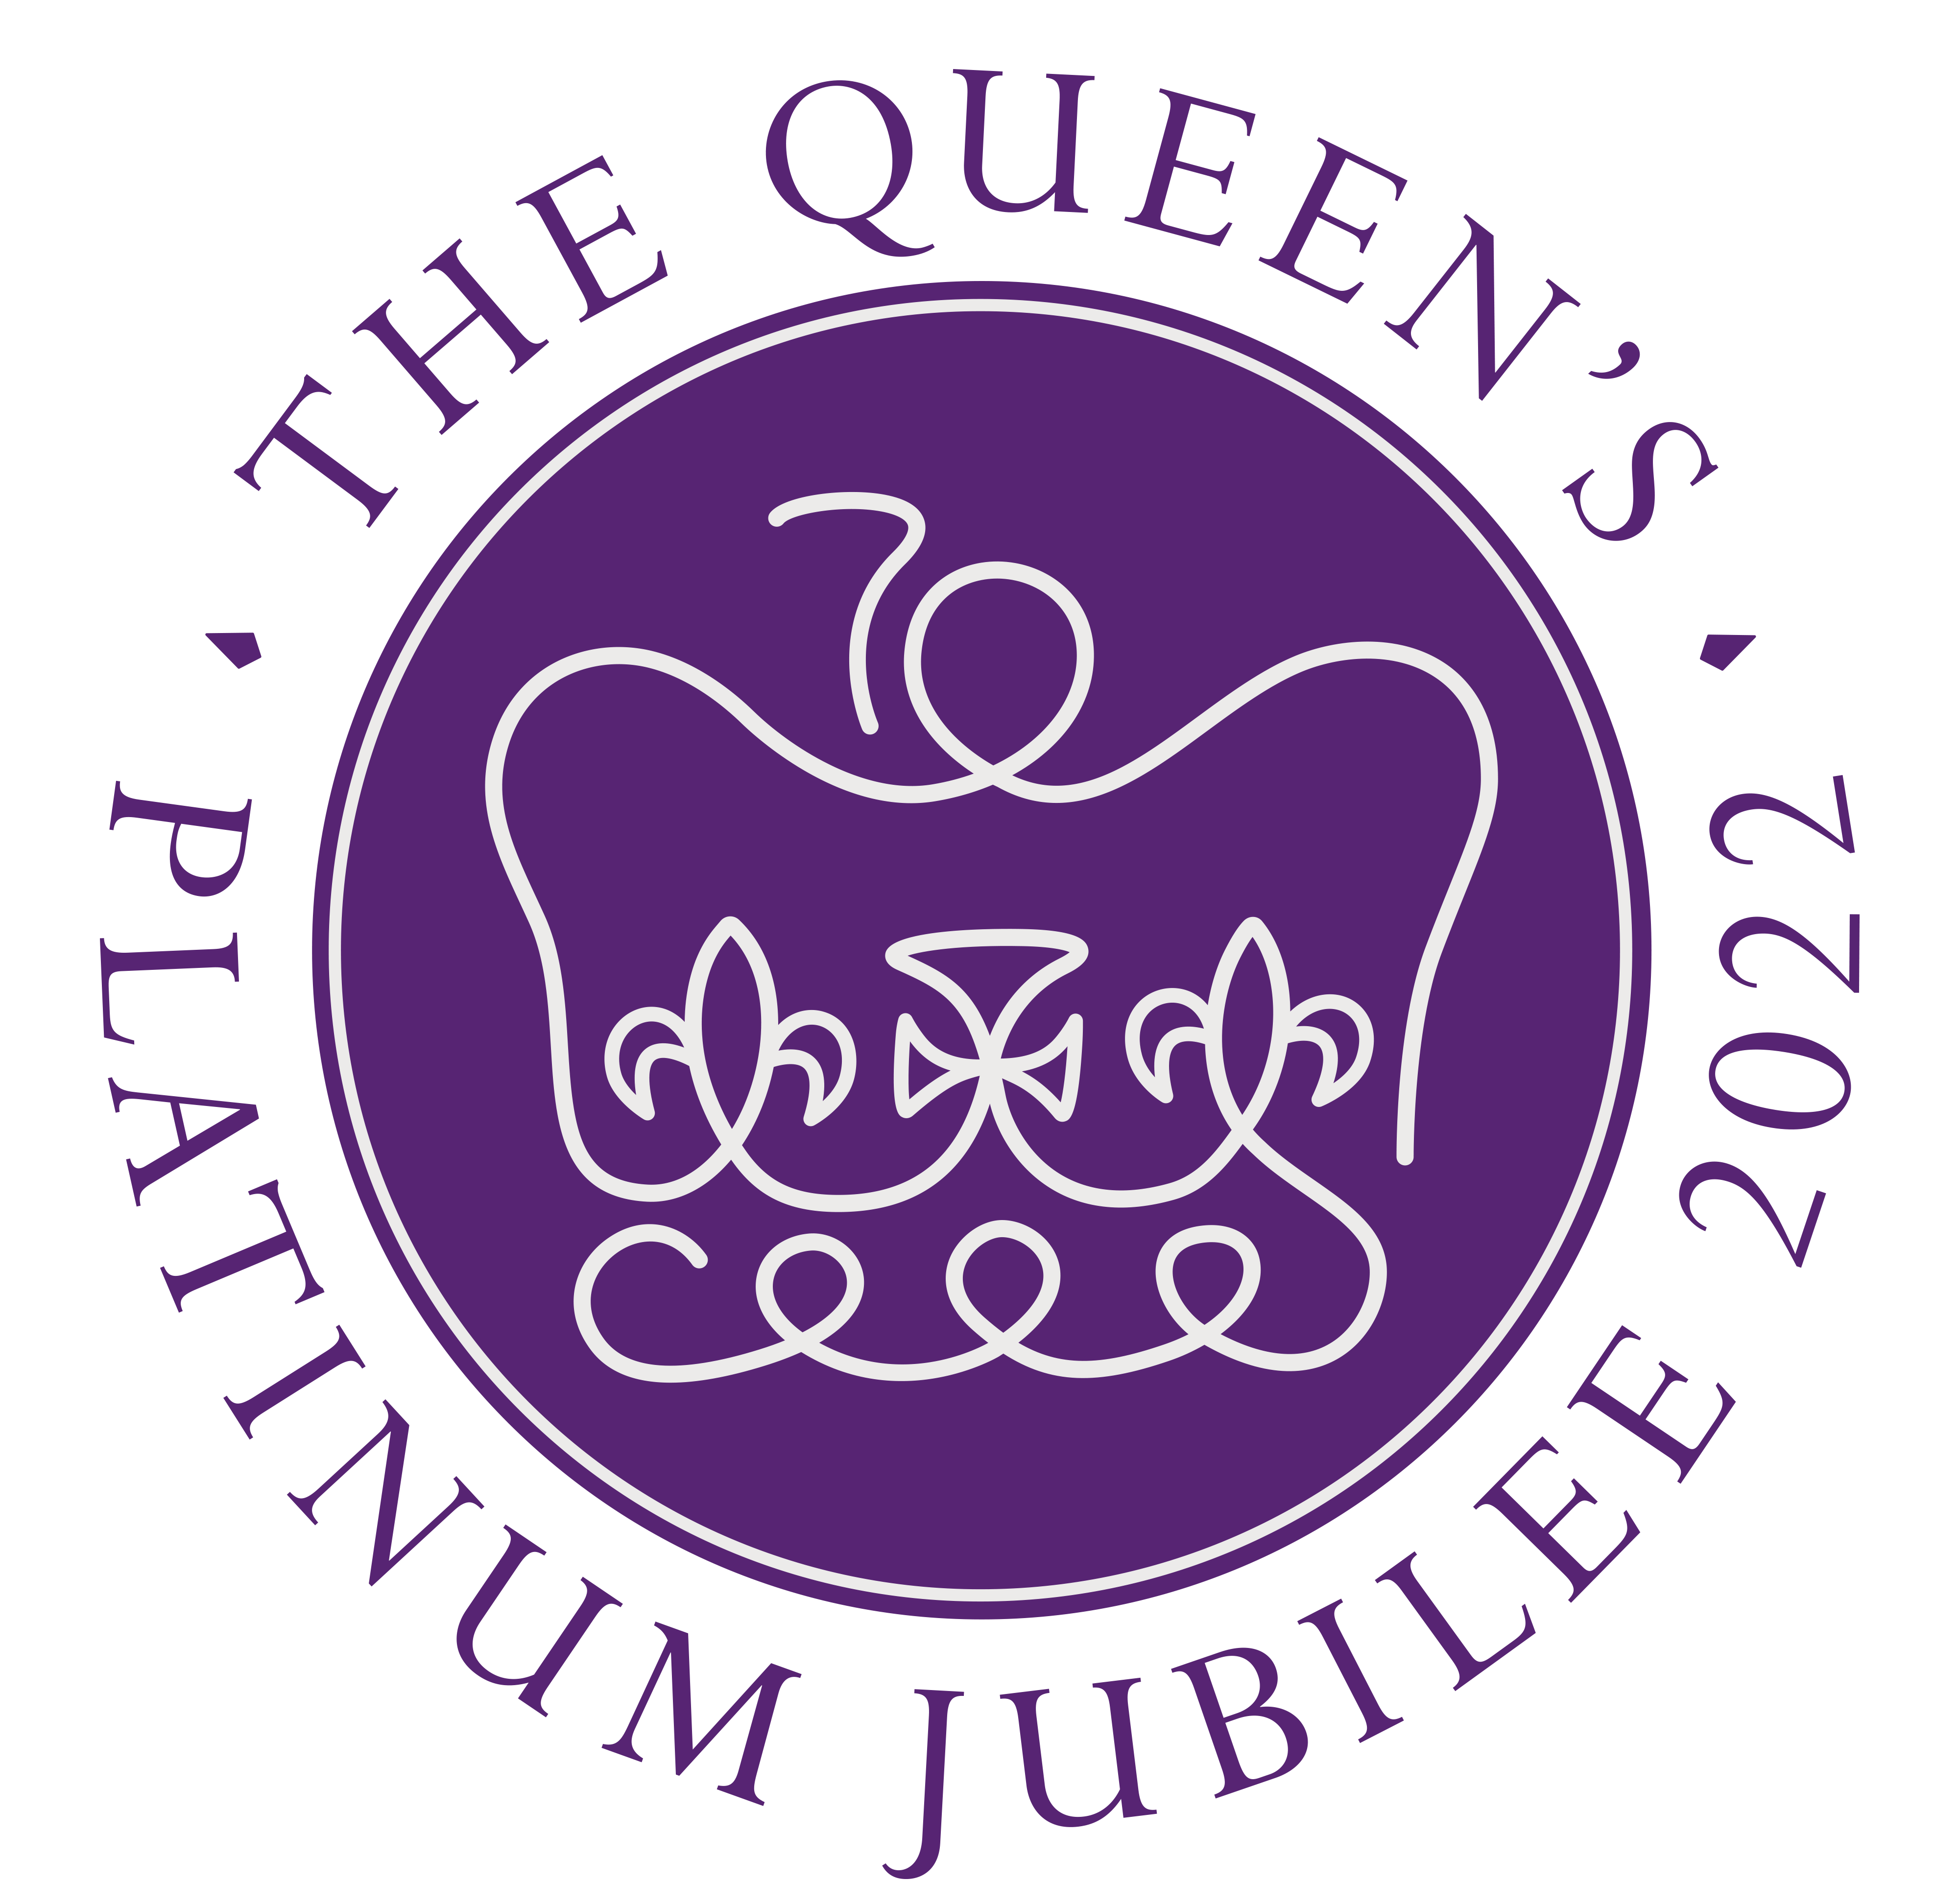
2 – 5 June 2022

On 6 February this year, Her Majesty The Queen became the first British Monarch to celebrate a Platinum Jubilee, marking 70 years of service to the people of the United Kingdom, the Realms and the Commonwealth. To celebrate this unprecedented anniversary, events and initiatives will take place throughout the year, culminating in a four-day UK bank holiday weekend from Thursday 2nd to Sunday 5th June. The bank holiday will provide an opportunity for communities and people throughout the United Kingdom to come together to celebrate the historic milestone.

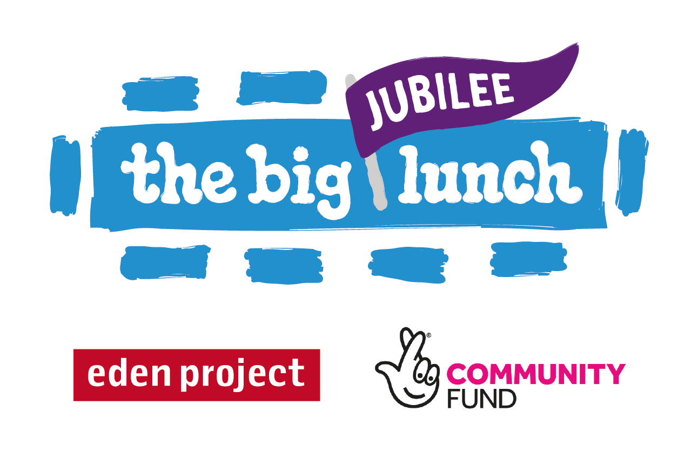
The Big Jubilee Lunch
Sunday 5 June 2022
Every year since the idea began in 2009, The Big Lunch has encouraged communities to celebrate their connections and get to know each other a little bit better, coming together in a spirit of fun and friendship. In 2022 The Big Lunch will bring the Jubilee celebrations into the heart of every community. People are invited to share friendship, food and fun with neighbours as part of the Platinum Jubilee celebrations. A Big Jubilee Lunch can be big or small - street party or picnic, tea and cake or a garden barbeque.

We are delighted to confirm that the NFWI will be supporting The Big Jubilee Lunch and encouraging WIs around the country to celebrate the Jubilee with fellow members, friends, family and the local community on Sunday 5th June 2022. Join Tracey Robbins, Head of UK Delivery, Big Jubilee Lunch, and Vicky Constantine-Foster, NFWI Membership Manager on Wednesday 2 March 2022 at 12.30pm to find out more about the event and how your WI can get involved. All WI members are welcome to join, but don't worry if you are not available, this session will be recorded and available to watch on My WI at a later date.

Please ensure you register in advance for this meeting:
https://us02web.zoom.us/meeting/register/tZwrd-ChqjsvEtwG1qkw7pisDY5bvl17H7eU

After registering, you will receive a confirmation email containing information about joining the meeting.

Have you organised a Big Lunch? If so, we want to hear from you! Ahead of the Big Jubilee Lunch this summer, we’re looking to hear from WI members who have been involved in organising a Big Lunch in the past, so we can celebrate these stories and help make this year’s event extra special.

If you have experience of organising and running a Big Lunch event, please get in touch at pr@nfwi.org.uk.

Thankbox Card
We wanted to mark the Platinum Jubilee by giving all WIs an opportunity to pass their celebratory messages and kind words to Buckingham Palace. To do this and be able to reach all WIs, we have decided to take the digital route. Please share this link below with your WIs and encourage as many as possible to upload their messages of congratulations, which will be shared with the Palace prior to the Jubilee celebrations…

https://www.thankbox.com/app/thankbox/twuhnhLb

Please be aware that during the initial upload stage, you may not be able to see all the contributions made by other WIs, so do not worry if you try to find a message from another WI and discover it’s not there. The system will process all messages when the card is closed and sent.

Deadline for submitting a message is Sunday 1 May 2022 at 5pm, after which the card will be closed, and no further messages can be accepted.

Where's WInnie?
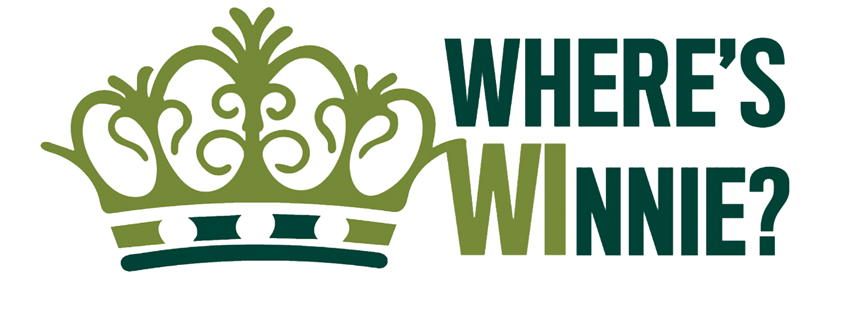

To honour The Queen’s longstanding relationship with the WI – she joined Sandringham WI, Norfolk Federation, in 1943 and remains its President – we’re asking members to take part in an exciting knitting project, to share and celebrate the Queen's Jubilee and pay the WI love forward and cheer up someone's day. Look out for the March issue of WI Life to find out more and register to attend a special knit-along session on Saturday 23 April 2022 at 10am.

Register in advance for this meeting:
https://us02web.zoom.us/meeting/register/tZUkcOuvqjgqH9QJ3WUvaR5-r4GPw5n-ITHI

WI Celebration Ideas
On the 2 May 2022, a special range of WI projects and recipes will go live on My WI, including guidance on how to set up a community event, membership advertisement, food labelling and allergen advice. We are keen to enable all women to be given the opportunity to join in the jubilee celebrations and will be providing members with ideas for creating a WI Jubilee Gift Box or Care Kit, which could be filled and gifted by WIs to a local food bank, women's refuge, or charity of their choice.

Save the date… Saturday 21 May 2022 Join the Cake Lady of Oxfordshire for a special Jubilee cake bake along. More details including registration link to follow soon.

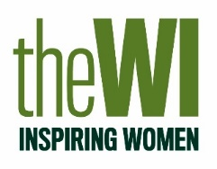
We will email all federations again nearer the time with a reminder of what will be available, how to access content and details of how you can share your images throughout the celebrations. In the meantime, if you have any questions, please contact the Activities team on activities@nfwi.org.uk

